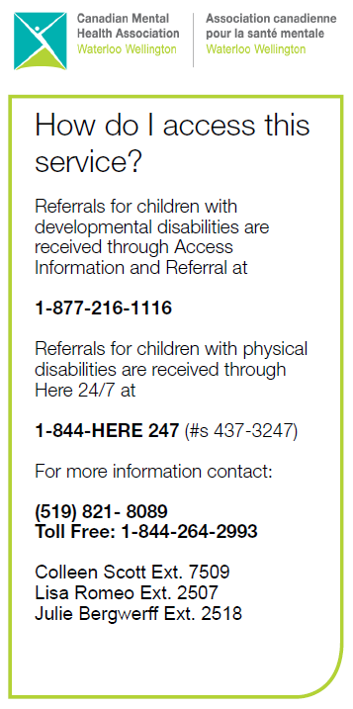

Coordinator Contact Info:

Call 1-844-264-2993

***Colleen Scott:***

extension 7509 OR [cscott@cmhaww.ca](mailto:cscott@cmhaww.ca)

***Julie Bergwerff:***

extension 2518 OR [jbergwerff@cmhaww.ca](mailto:jbergwerff@cmhaww.ca)

***Lisa Romeo:***

extension 2507 OR lromeo@cmhaww.ca

Happy New Year to everyone!

We hope this latest update finds you and your families all doing well!

The end of the 2023/2024 fiscal year is coming up on March 31, 2024. If you haven’t submitted invoices, please do so now! If you have questions about contract balances, item eligibility or need help with invoices please get in touch with your Coordinator.

Sincerely,

Colleen, Julie & Lisa ~ FSO Coordinators

**\*\* 2023 – 2024 FISCAL YEAR ENDS SOON\*\***

**The current fiscal year will come to an end on March 31, 2024.**

**The last submission date for the 2023/2024 fiscal year is April 9, 2024 by 8AM.**

**If you haven’t submitted invoices, please do so now. Please do not wait until year end to submit all your invoices.**



**CMHA Staff Announcement**

We wanted to let you know that Colleen Scott has decided to retire, after 30+ years of service with our agency. Colleen’s last day with us will be April 30, 2024.

We are sad to see our friend go, but so happy for her at the same time! We wish Colleen all the best as she begins this new chapter of her life. Thank you, Colleen, for your dedication and all your support to help the children & families in our community.

For families who are currently being supported by Colleen, a new Coordinator has been hired and will begin working with the Family Support Options program in February. Her name is Cheryl Van Every-Petty and we would like to welcome Cheryl to our team!

**ITEM ELIGIBILITY**

We continue to receive many invoices for items that the Ministry is no longer allowing families to claim. Some examples of items we see that are no longer eligible include:

* Videogame consoles & video games
* Recreational or fitness items for use off your home property
* Streaming subscriptions (eg: Netflix, Disney+, Spotify, Amazon, etc…)
* Cell phones and monthly plans

Please refer to the Ministry’s website at <https://www.ontario.ca/page/special-services-home> and click on #8 – “List of services you can purchase” for an updated list of eligible items.

If there is a specific item you are still wondering about, please contact your Coordinator before purchasing.

**OFFICE UPDATE: SILVERCREEK OFFICE IS CLOSED**

Our CMHA office that was located on Silvercreek Parkway is now closed. We are in the process of moving into our new site located at 737 Woolwich Street (Guelph).

Visit our website at <https://cmhaww.ca/newbuilding/> for all the latest updates regarding our new Children and Youth Services building. We are all very excited about it!

**My Direct Plan Information**

When you receive your new authorization letter for the 2024/2025 fiscal year, please DO NOT sign up for the My Direct Plan app.

The My Direct Plan app is solely for families who are self-administering their funds and are dealing with the Ministry directly.

We are currently planning our SKIC program for Summer 2024, with registration opening April 2, 2024, at 12:00 pm.

Contact Luis Sandoval, Supporting Kids in Camp Coordinator if you have any questions at [skic@cmhaww.ca](mailto:skic@cmhaww.ca)

Visit <https://cmhaww.ca/services/skic/> for more program information and all the latest SKIC updates!

*Has your contact information changed? Let your Coordinator know! This includes change of address, phone number, or email address.*

*Planning to move? Let us know!*

