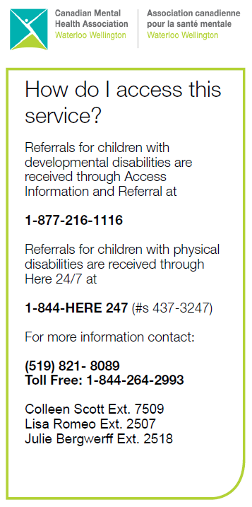
**NEW for 2023 – 2024 Fiscal Year**
Effective April 1, 2023 - CMHA WW will process invoices on the 2nd and 4th Tuesday of each month.
Invoices are due by 8AM on those days. Any invoices that are incomplete or require follow up will be returned to families.
Coordinator Contact Info:
Call 1-844-264-2993
Colleen Scott:
extension 7509 OR cscott@cmhaww.ca
Julie Bergwerff:
extension 2518 OR jbergwerff@cmhaww.ca
Lisa Romeo:
extension 2507 OR lromeo@cmhaww.ca

Greetings SSAH Families!

We hope everyone is doing well and getting ready to enjoy this summer.
This new fiscal year has brought about many changes – changes from the Ministry regarding eligible items for reimbursement and a subsequent change to our CMHA invoice to reflect this. Please begin using the new invoice included in this mailout and recycle/delete any previous versions you may have.
Contact your Coordinator if you have questions or need help with invoices.
Sincerely,
Colleen, Julie & Lisa ~ FSO Coordinators

CHANGES TO ELIGIBLE ITEMS FOR PURCHASE

Beginning April 1, 2023 the Ministry of Children, Community & Social Services implemented changes as to what items are now eligible for reimbursement through the SSAH & MFTD programs. You should have received information regarding these changes in the authorization packages forwarded to you in the mail by the Ministry.
To find out more about these new changes, please visit the Ministry’s website at https://www.ontario.ca/document/special-services-home-program-guidelines. We encourage you to review these changes carefully, as many items that were previously eligible are no longer eligible for reimbursement.
**Please call your Coordinator before buying to ensure item eligibility. Any items claimed on SSAH/MFTD invoices that are not eligible will be removed and will be your responsibility to cover.

**NEW – REVISED CMHA INVOICE:
- As a result of the $1500 cap on technology items we revised our CMHA invoice to include a line to reflect technology purchases being claimed.
- Amounts spent above the $1500 cap for items considered as technology are your responsibility to cover.
- The revised invoice is included in this mailout, so please begin using it immediately.
- If you need help filling out invoices you can contact your Coordinator.
- Our invoice will be posted on our web page at https://cmhaww.ca/programs/childrens-services/family-support-options/ located in the “Invoice Information” tab.

Looking for respite? Try the respiteservices.com website.
If you are interested in respite support, please visit www.respiteservices.com to learn about options in Guelph and Wellington County. This site allows you to create a personal profile and receive information about independent support providers in the area.
Contact Laura McDonald, Recruitment and Training Coordinator, at respite@cmhaww.ca for more details.

Has your contact information changed? Let your Coordinator know! This includes change of address, phone number, or email address.
Planning to move? Let us know!

