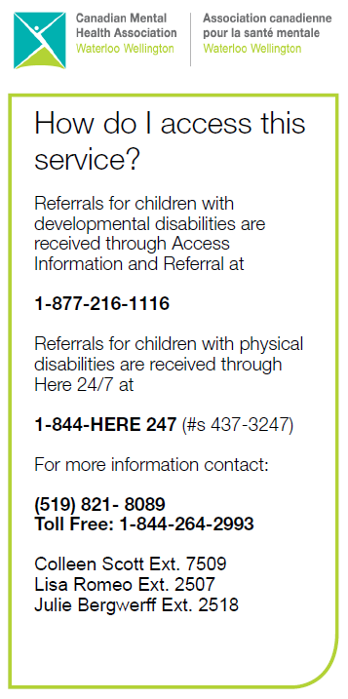
Coordinator Contact Info:
Call 1-844-264-2993
Colleen Scott:
extension 7509 OR cscott@cmhaww.ca
Julie Bergwerff:
extension 2518 OR jbergwerff@cmhaww.ca
Lisa Romeo:
extension 2507 OR lromeo@cmhaww.ca
Hello SSAH Families!

We hope that everyone is doing well, and looking forward to the summer!
This update contains important information about our NEW system for processing invoices. These changes will be effective July 5, 2022. Please take the time to review the information below, and as always, feel free to contact your Coordinator if you have any questions.
We are rolling out a NEW CMHA invoice, included in this mailout. Please start using this immediately.
We appreciate your cooperation and support to make this transition as smooth as possible!
Sincerely,
Colleen, Julie & Lisa ~ FSO Coordinators
NEW!! Updated system for processing invoices
- Effective July 5, 2022 – Invoices will be processed every other Tuesday. Due to the increased invoices & receipts we are currently receiving as a result of the temporary exceptions, CMHA has made the decision to move to this model to allow us an opportunity to process invoices on a more frequent basis and reimburse families more quickly.
- Additionally, we will no longer be accepting invoices via fax, after September 27, 2022.
- For your reference, we’ve included a table (see below) to indicate the new invoice due dates for the 2022-2023 fiscal year. Invoices are due on the days below by 8AM.
July 5, 2022 | December 6, 2022
July 19, 2022 | December 20, 2022
August 2, 2022 | January 3, 2023
August 16, 2022 | January 17, 2023
August 30, 2022 | January 31, 2023
September 13, 2022 | February 14, 2023
September 27, 2022 *LAST DAY FOR FAXES | February 28, 2023
October 11, 2022 | March 14, 2023
October 25, 2022 | March 28, 2023
November 8, 2022 | April 11, 2023 *ALL INVOICES DUE YEAR END
November 22, 2022

July 5, 2022 | December 6, 2022
July 19, 2022 | December 20, 2022
August 2, 2022 | January 3, 2023
August 16, 2022 | January 17, 2023
August 30, 2022 | January 31, 2023
September 13, 2022 | February 14, 2023
September 27, 2022 *LAST DAY FOR FAXES | February 28, 2023
October 11, 2022 | March 14, 2023
October 25, 2022 | March 28, 2023
November 8, 2022 | April 11, 2023 *ALL INVOICES DUE YEAR END
November 22, 2022

- Once your invoice has been received by CMHA, it will be processed within 10 to 15 business days. A cheque will be sent out in the mail shortly after.
- Families can continue to use the following options to submit invoices:
- Email – ssahinvoices@cmhaww.ca
- Mail OR drop off invoices in person to the mail boxes located at your closest CMHA office. Please ensure any mailed or dropped off in person paperwork is labelled SSAH (please do not address to your Coordinator as this will cause delay for reimbursement).

NEW!! CMHA Invoice
- As a result of the above changes, we have also revised our CMHA invoice. It’s included as part of this mailout, so please begin using this now! If you need a copy emailed to you, please reach out to your Coordinator.
- We realize there have been ongoing issues with our online invoice that is located on our web-page. We are working to resolve these issues and will notify families once this is back up and running. Please stay tuned to our web page for updates!

We would like to thank everyone in advance for your help with the transition over to this new way of doing things. We will be working on ensuring the information is also updated on our web page at https://cmhaww.ca/programs-services/childrens-services/family-support-options/
As always, please contact your Coordinator if you have questions.

Has your contact information changed? Please remember to let your Coordinator know! This includes change of address, phone number, or email address. Families are also obligated to inform the Ministry of any changes to contact information.
Planning to move? Let us know!

