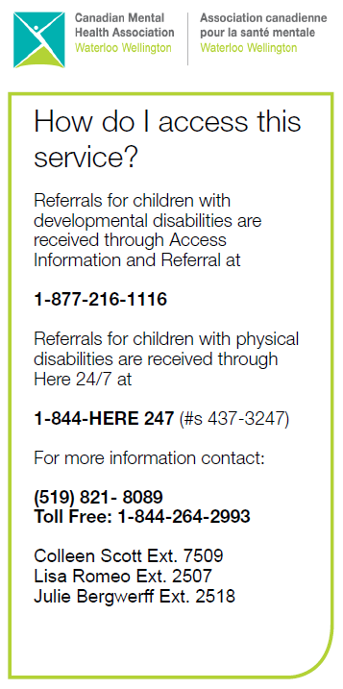
Supporting Kids in Camp (SKIC) - We support children with physical and/or developmental needs at day camps. Registration for Summer 2023 will open April 1, 2023. Visit us at www.cmhaww.ca/skic
Looking for Respite Care? Check out www.respiteservices.com , a database that allows families and respite workers to create profiles and connect with each other.
Questions? Contact Laura McDonald, Recruitment and Training Coordinator, at 1-844-264-2993 extension 7055 OR lmcdonald@cmhaww.ca

Coordinator Contact Info:
Call 1-844-264-2993
Colleen Scott:
extension 7509 OR cscott@cmhaww.ca
Julie Bergwerff:
extension 2518 OR jbergwerff@cmhaww.ca
Lisa Romeo:
extension 2507 OR lromeo@cmhaww.ca

Hello SSAH Families!

Summer has gone by so quickly! We hope you are all doing well as we approach the fall and winter months.
Please continue to use our web page as a reference for our program. There is lots of useful information about Family Support Options, and how the program is administered through CMHA WW. Our web page also includes links to important documents like our newly revised CMHA invoice. Please visit www.cmhaww.ca/fso and save it to your favourites! Suggestions or feedback is always welcome – just forward your thoughts on to your Coordinator!
Take care,
Colleen, Julie & Lisa ~ FSO Coordinators

SSAH & MFTD Contract Increases - NEW
- Recently, you should have received a letter from the Ministry regarding funding increases to SSAH and MFTD contracts. Some important highlights about the increases include the following:
- Special Services At Home (SSAH) contracts will receive a 10% increase to the previously approved amount.
- Medically Fragile Technology Dependent (MFTD) contracts will receive an 18% increase to the previously approved amount.
- The amount identified in the letter from the Ministry is the total amount of funding this year and NOT in addition to funds already available.
- Both of these increases have been pro-rated from July 2022 to March 2023.
- Any amounts due in excess of the funds remaining with CMHA WW are the responsibility of the parent/guardian. CMHA WW is not responsible for any discrepancies or errors in the funding amounts communicated by the Ministry.
- The Ministry is allowing families to use the funds according to the guidelines already in place. For more information about how to use funds appropriately, please visit the Ministry website at https://www.ontario.ca/page/special-services-home. As always, if there is something specific you are wondering about that is not included in the list of eligible items, please call your Coordinator before purchasing anything.
Processing Deadlines/New CMHA Invoice – REMINDERS
- Effective July 5, 2022, we changed the processing deadlines to every other Tuesday. Invoices are due by 8AM on the dates indicated, and a cheque will be put in the mail to you within 15 business days of the applicable deadline date. Any discrepancies in the invoices and receipts will result in a delay in processing, and invoices may be returned for further follow up.
- Due to the significantly higher volume of invoices & receipts we are receiving as a result of the temporary exceptions currently in place, it’s taking us longer to get through all the invoices. If you’ve submitted an invoice and haven’t received your reimbursement within 30 days, please connect with your Coordinator. Please do not re-submit your invoice unless your Coordinator asks you to do so.
- Included in this mailout is the newly revised CMHA invoice. Many thanks to the families who have already begun using it; for those who haven’t please do so as soon as you are able and recycle any copies of your old invoices.
- Effective September 27, 2022 we are no longer accepting invoices via fax. Invoices received via fax after this date will be returned and result in a delay in processing.
- Invoices with 5 or more receipts need to be dropped off in person to one of the designated CMHA offices as indicated on page 2 of the CMHA invoice. Please provide copies only of your receipts and keep the originals.
- Here is a list of the remaining deadline dates for this fiscal year:
October 25, 2022 | January 31, 2023
November 8, 2022 | February 14, 2023
November 22, 2022 | February 28, 2023
December 6, 2022 | March 14, 2023
December 20, 2022 | March 28, 2023
January 3, 2023 | April 11, 2023  *ALL INVOICES DUE FOR YEAR END
January 17, 2023

Online Invoice – UPDATE: Due to ongoing technical difficulties, we made the decision to eliminate our online invoice. Families can still email invoices to our SSAH email at ssahinvoices@cmhaww.ca
Has your contact information changed? Please remember to let your Coordinator know! This includes change of address, phone number, or email address.
Planning to move? Let us know!

